Project Development Phase
Model Performance Test

Date | 19 February 2026
Team ID | LTVIP2026TMIDS77295
Project Name | Smart Sorting: Transfer Learning for Identifying Rotten Fruits and Vegetables.

Model Performance Testing:
Project team shall fill the following information in model performance testing template.
S.No. | Parameter | Values | Screenshot
 | Metrics | Regression Model:  Not Applicable (Project is Classification-based, not Regression). | ----
 | Metrics | Classification Model:  Confusion Matrix:  True Positive (Rotten): 311  True Negative (Fresh): 331  False Positive: 7  False Negative: 11  Accuracy Score: 97%  Classification Report:  Precision: 97%  Recall: 98%  F1-Score: 97%  Support: 660 samples | 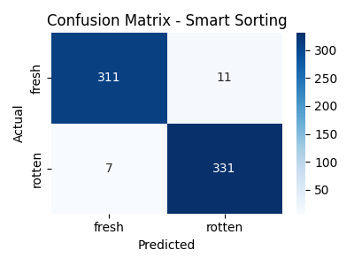  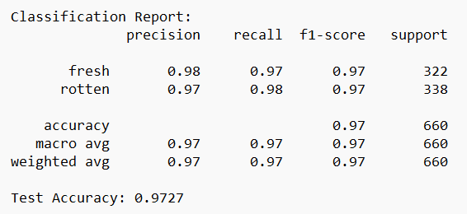
 | Tune the Model | Hyperparameter Tuning –  Learning Rate: 0.001 → 0.0001 (after tuning)  Batch Size: 32  Epochs: 10 (fine tuning)  Optimizer: Adam  Dropout: 0.5 (added to reduce overfitting)  Validation Method –  80% Training Data  20% Validation Data Split  Stratified Sampling Used  Early Stopping Applied (Patience = 5 epochs)

